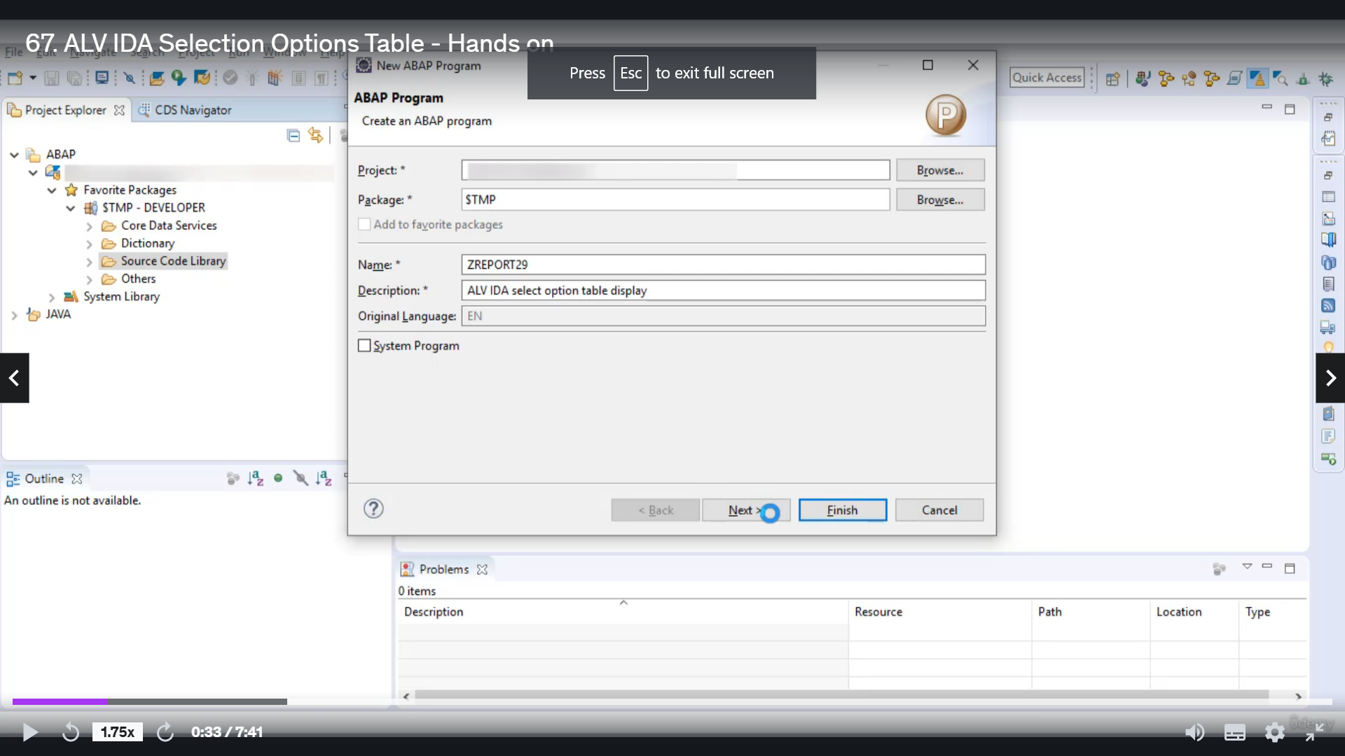

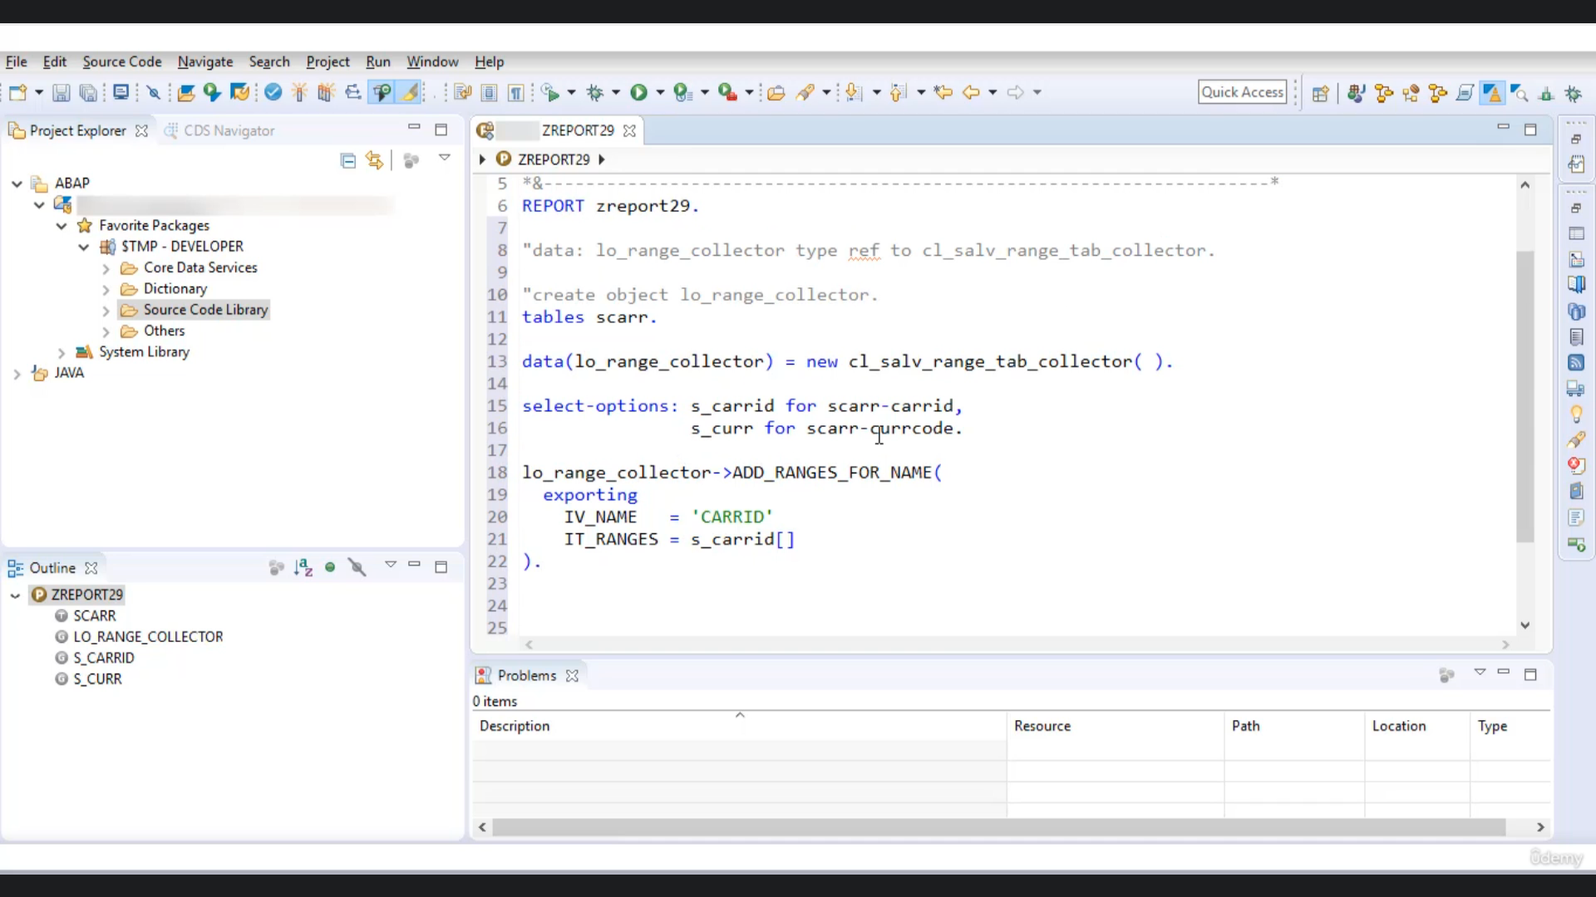

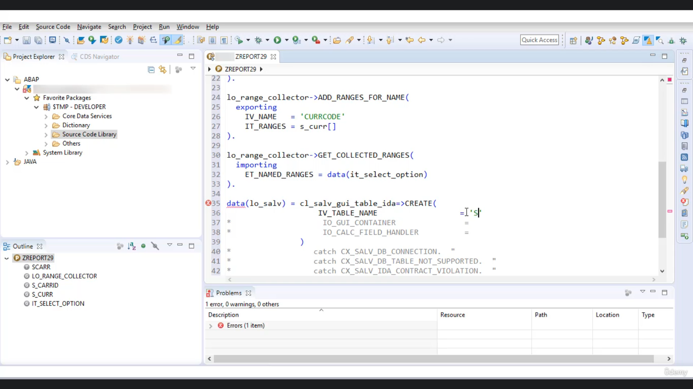

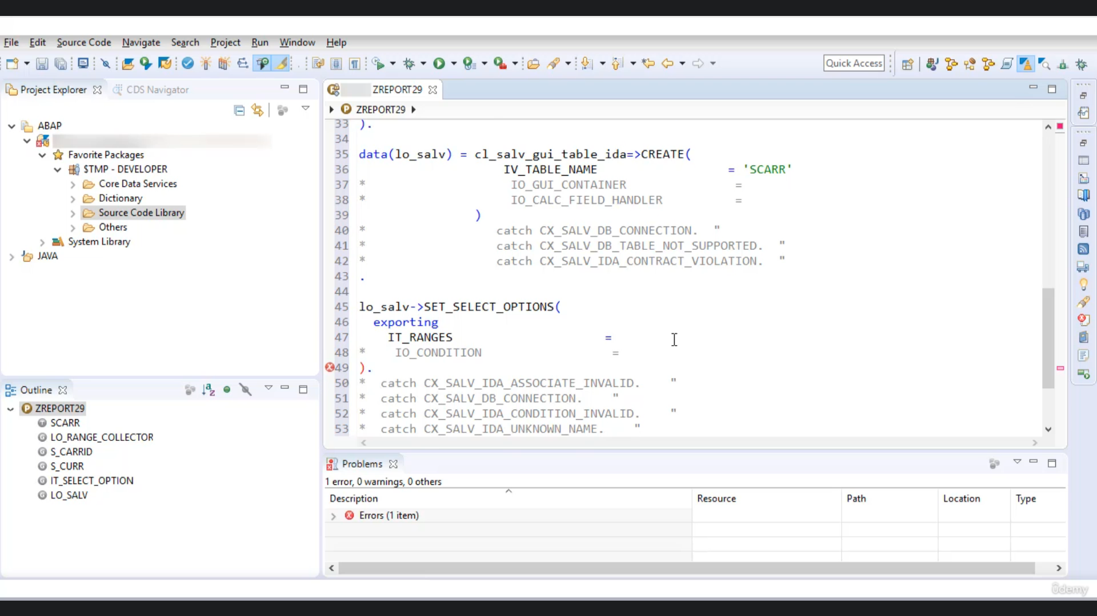

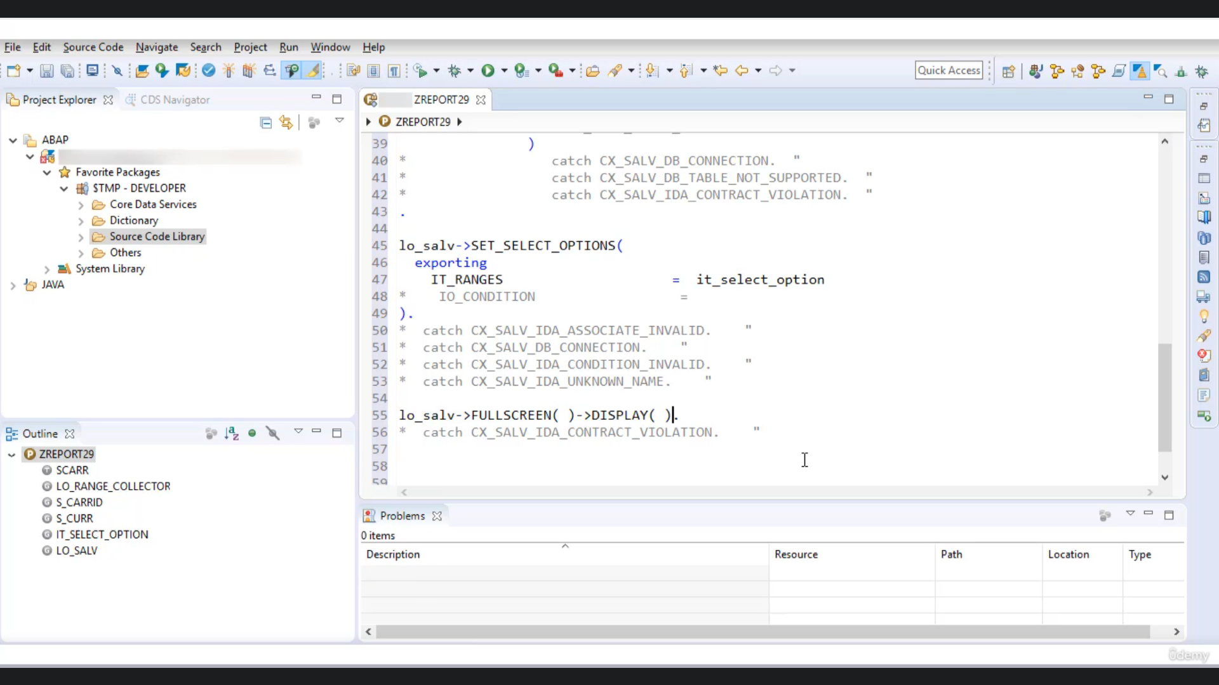

Let's create a baby food program.

Whitney, the triple twenty nine, let let's give you a description as.

Aliabadi, select option table displaying.

Now let's create one defense variable name L'Orange collected yourself type refer to class SLV range

Deb Collector.

Now, let's create object.

Upclose is a village debt collector.

OK.

If you don't want to use this to statement and if you want to read it in a single statement, then you

can try to collect this data, then you have to specify object name.

Then be your new and your to type class name.

OK, here we are getting it, because we have already declared, if you comment on this line.

Then you can see there is no air, so this is another way.

This is what we call a line declaration.

Now, let's select option.

Name is Corradi for.

Garet.

So here we go.

Tornado Etgar Keret is unknown to the this theater, you have to specify your table's.

Scott, OK, no using instant l'orange collector to get called to make tote.

Attorneys for name.

Now you have to specify the name of free garatti.

And ranges haciendas could guarantee.

Let's say I want to use one more select option.

It's underscored currency code for.

Free currency of the world, Scott.

OK, so we got one radio.

OK, the link is more here, so simple are right is sea water, since we are using one more select option

here.

So you have to again, use our brains for names and you're your are for these changes for field.

Currency called.

And it ranges has underscored good.

Now we have to collect these ranges into one alternative, but so for that purpose, you have to call

to method get collected range.

Get collected, Rangers'.

Let's say I want to collect the Rangers into internal debate, I'd select option.

No yoku call to.

Matter of class, a salvager, electability.

So here you have grade class SLV, you do Baladi.

And then you are to give a call to me to create and here you have to pass the names of people that you

want to display here.

I want to display content from tables called.

Now, using instruments will be your call to select select option method.

And here you are to pass value to.

I did reach here, you have to pass all the dangers that we have collected in internal debate.

I did select option lower class here to Google, to Materne.

Fullscreen.

And then to my third.

Display.

OK, so now there is no other activity called.

And execute.

So we got our select options.

Let's look at it as a currency at USD and execute.

So here is the output, there is only one record present which matches a given condition.

So if I do say and again execute, so you will get all the records reoccurrences USD.

So this is all you can you select option to filter out the timetable that you want to display using

a video?

Alvida that's it for now.

Have a nice day.